**HTML Lab Exercise 1**

1. Create a webpage that prints your name to the screen.

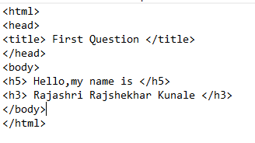

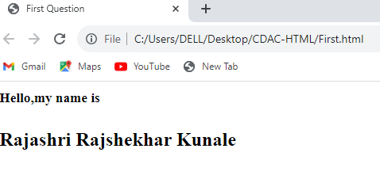

1. Create a webpage that prints the numbers 1 - 10 to the screen.

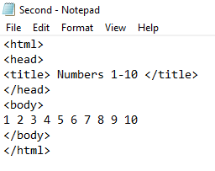

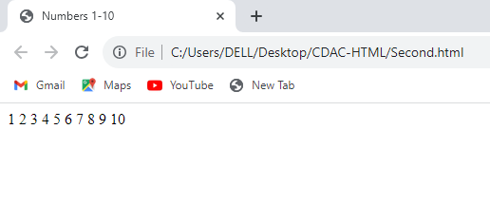

1. Create a webpage and set its title to "This is a webpage".

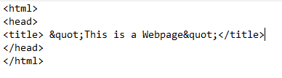

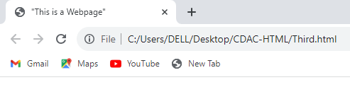

1. Create a webpage that prints the message "When was this webpage created? Check page's title for the answer." to the screen, and set the title of the page to the current date.

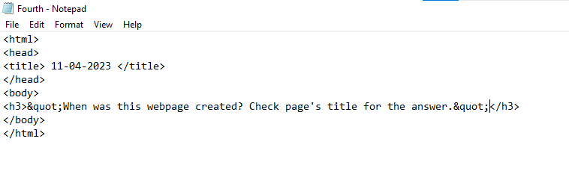

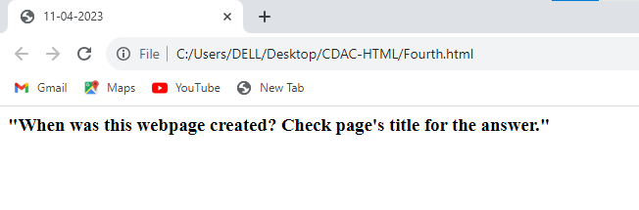

1. Create a webpage that prints any text of your choosing to the screen, do not include a head section in the code.

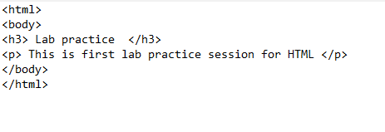

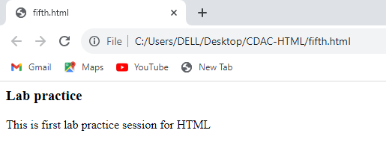

1. Repeat exercise #5, but this time include a head section in the code.

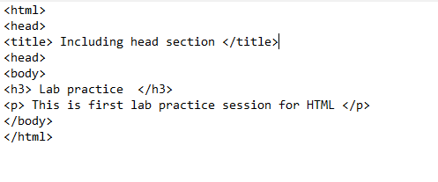

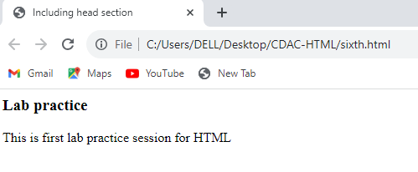

1. Print the squares of the numbers 1 - 20. Each number should be on a separate line, next to it the number 2 superscripted, an equal sign and the result. (Example: 102 = 100)

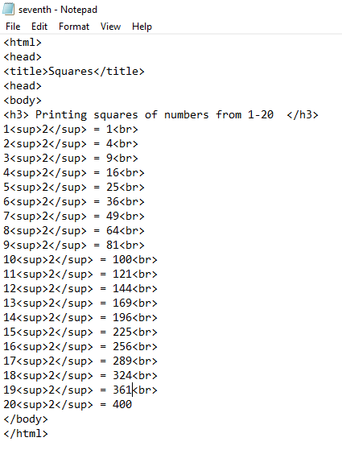

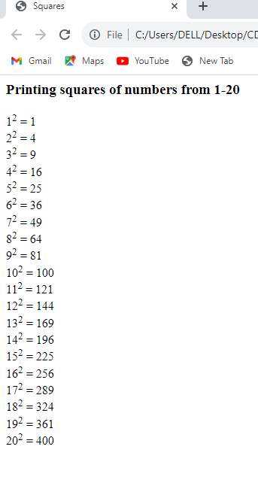

1. Prints 10 names with a line break between each name. The list should be alphabetized, and to do this place a subscripted number next to each name based on where it will go in the alphabetized list. (Example: Alan1). Print first, the unalphabetized list with a subscript number next to each name, then the alphabetized list. Both lists should have an <h1> level heading.

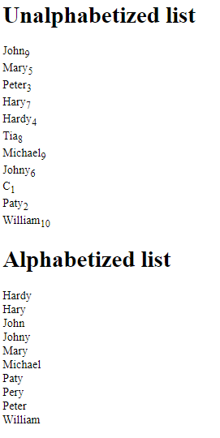

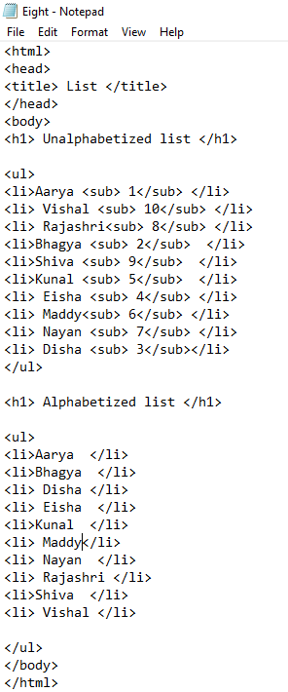

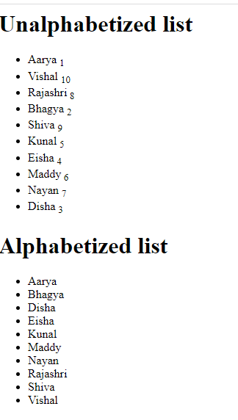

1. Print two paragraphs that are both indented using the &nbsp; command.

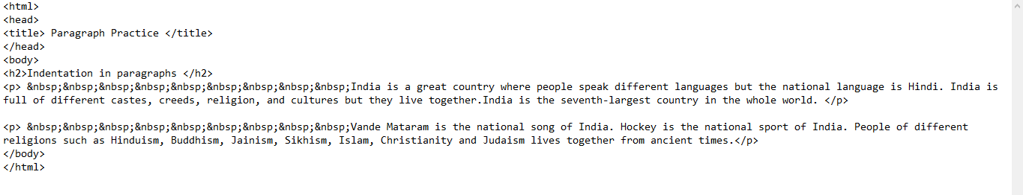



1. Print two lists with any information you want. One list should be an ordered list, the other list should be an unordered list.

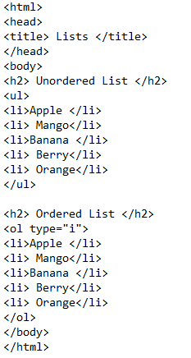

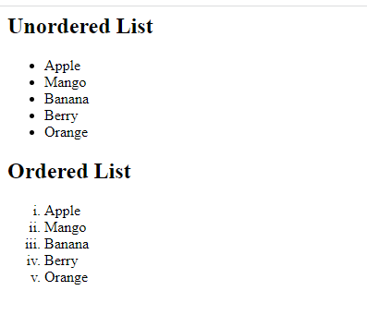

1. Prints an h1 level heading followed by a horizontal line whose width is 100%. Below the horizontal line print a paragraph relating to the text in the heading.

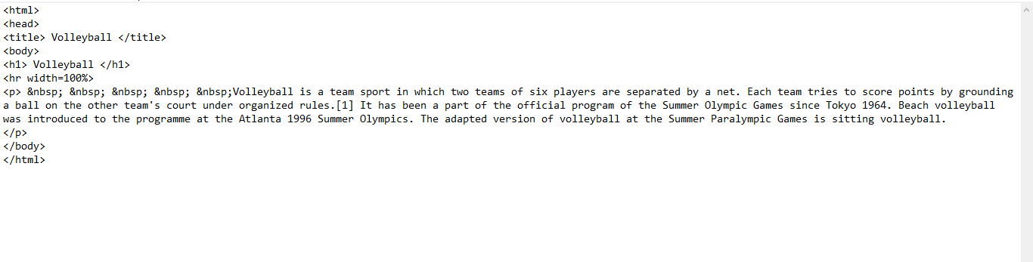

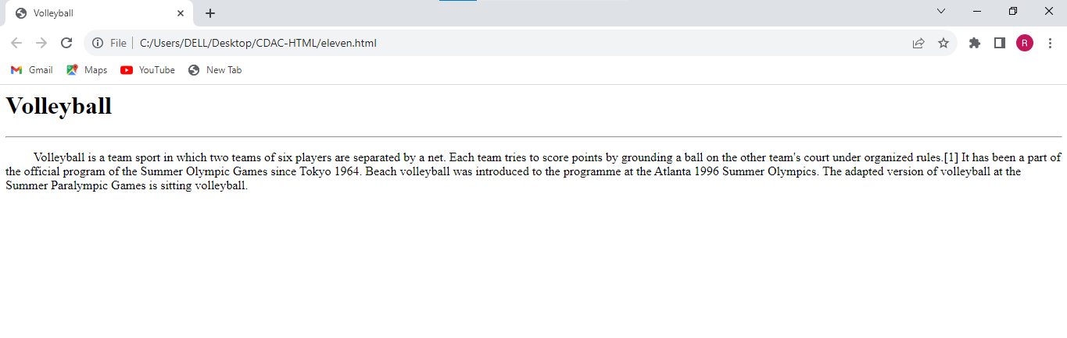

1. Print some preformatted text of your choice.

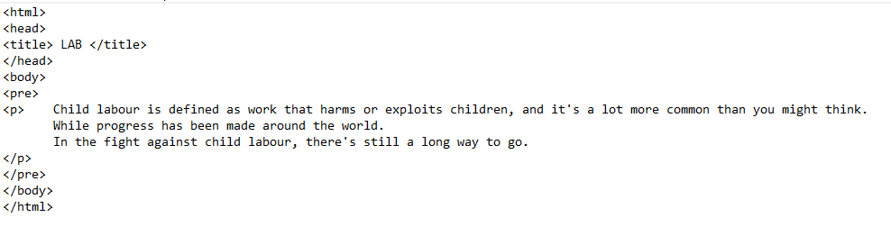



1. Print a definition list with 5 items.

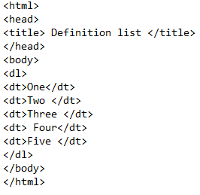

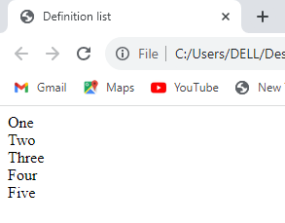

1. Print ten acronyms and abbreviations of your choosing, each separated by two lines. Specify the data that the abbreviations and acronyms represent.

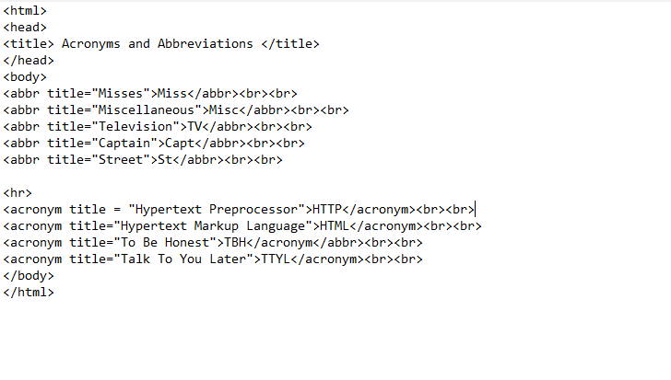

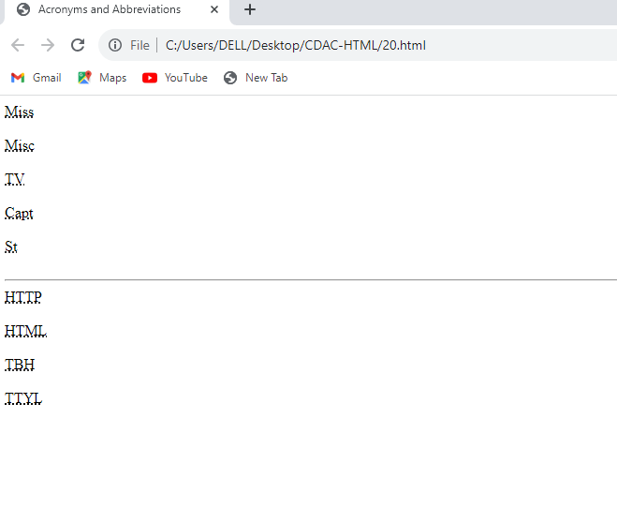

1. Create some links to various search engines (google, yahoo, altavista, lycos, etc).

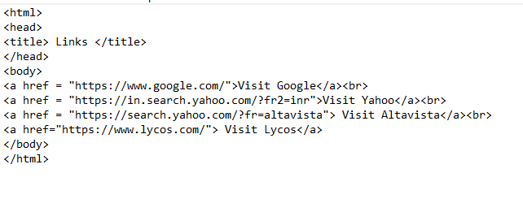

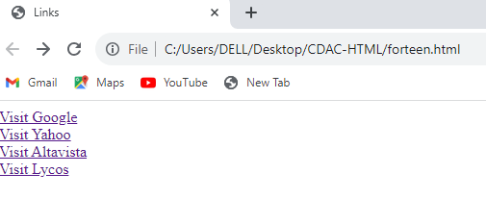

1. Create links to five different pages on five different websites that should all open in a new window.

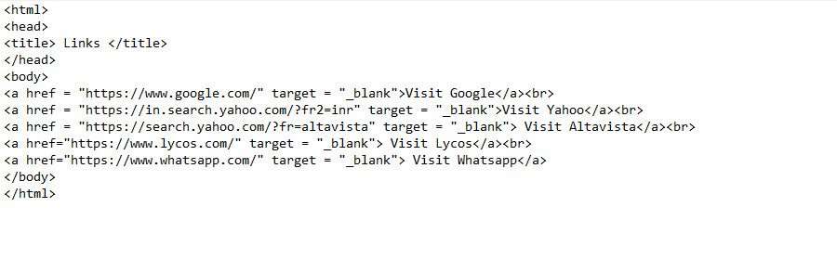

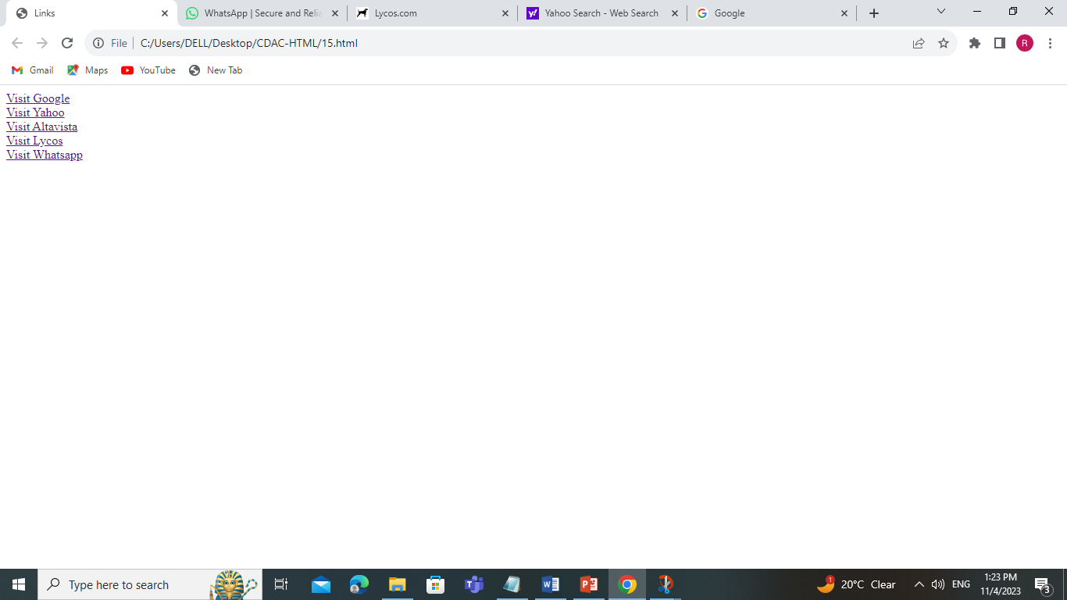

1. Create a page with a link at the top of it that when clicked will jump all the way to the bottom of the page.

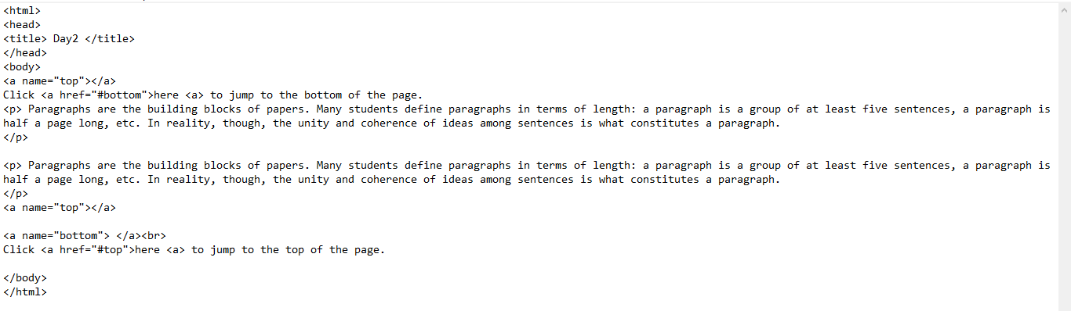

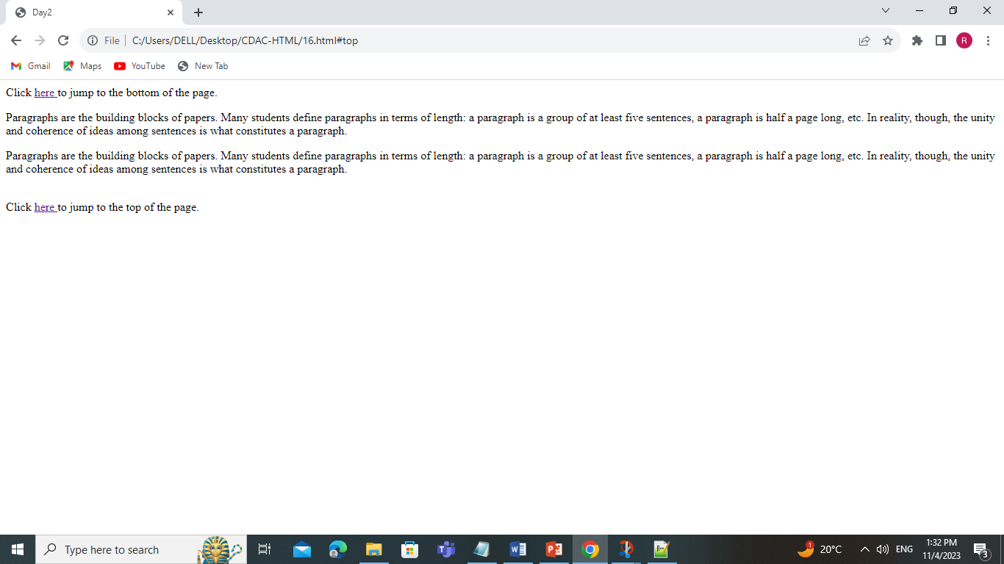

1. Display five different images. Skip two lines between each image. Each image should have a title.

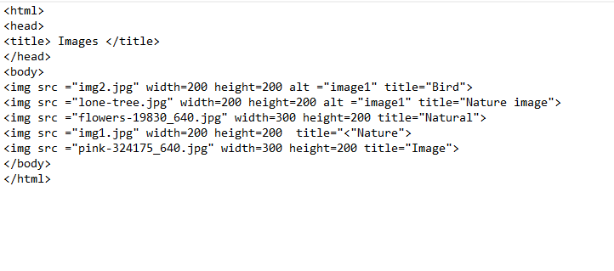

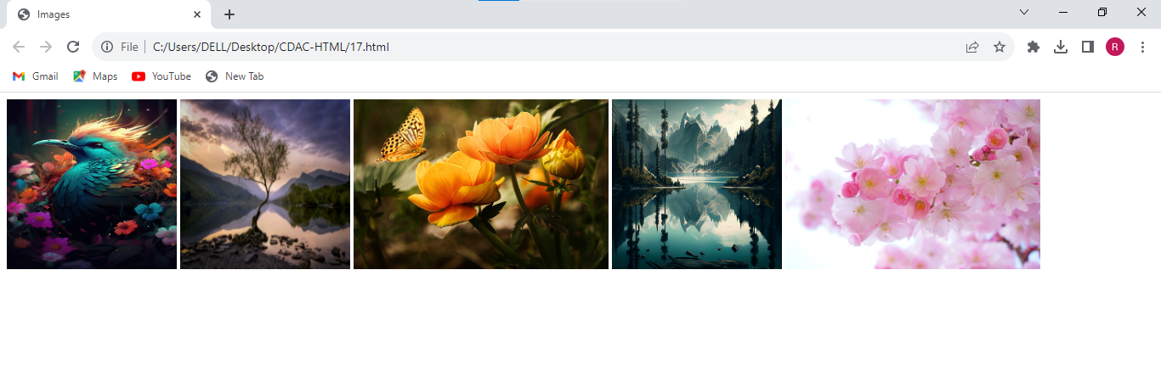

1. Display an image that has a width of 200, and a height of 200.

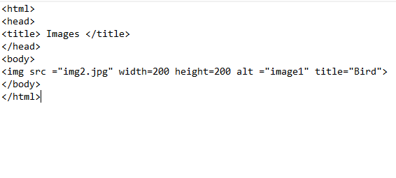

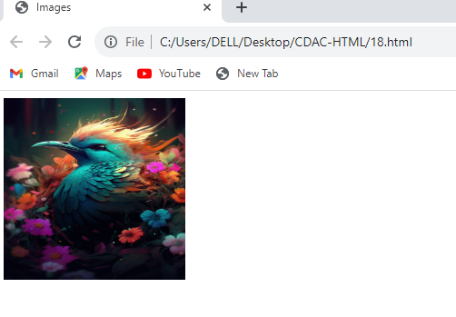

1. Display an image that when clicked will link to a search engine of your choice (should be opened in a new window).

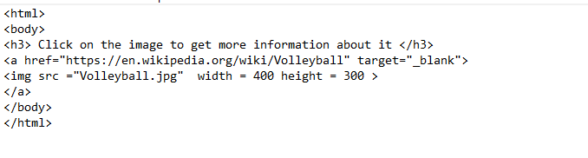

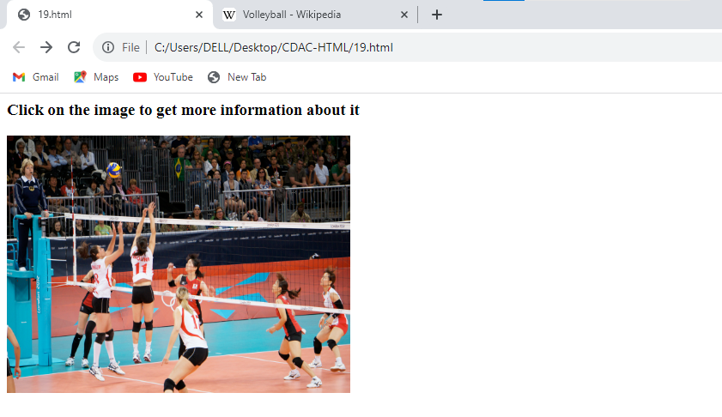

1. Display an image that when clicked will link to itself and will display the image in the browser by itself.

